**Awais Amin(F2021395)**

**Ammara Amin(F2021394)**

**Title: BOLT (Accessible and Affordable 3D Printer for Pakistan)**

**Introduction:**

Traditionally in Pakistan, manufacturing processes have been constrained by techniques such as machining, molding, casting, and subtractive manufacturing. These conventional methods often come with limitations, including high costs, extended production times, and limited design flexibility. In contrast, 3D printing offers a revolutionary approach to manufacturing, enabling dynamic, adaptive, and rapid prototyping across various industries, including engineering, building design, and more.

Pakistan faces challenges in the fields of manufacturing and hardware development, resulting in limited access to advanced technologies like 3D printing. To address this issue and promote the widespread adoption of 3D printing for hobbies, education, and manufacturing, we propose the development of an accessible and affordable 3D printer. This initiative aims to cater to the needs of individuals and organizations across Pakistan, fostering technological innovation and accessibility.

**Existing 3D Printers in Pakistan:**

Currently, imported 3D printers, such as the Prusa i3 and its clones, dominate the market in Pakistan, leading to high prices and restricted accessibility. These imported models often suffer from limitations, including:

**1. High Cost:** Imported 3D printers, like the Prusa i3, come with a hefty price tag, limiting their accessibility to a select few.

**2. Limited Build Volume:** Local Prusa i3 clones often offer constrained build volumes, limiting their utility for larger projects and batch production.

**3. Technical Expertise:** Operating and maintaining existing 3D printers typically requires technical expertise, creating a barrier to entry for novice users.

|  |  |  |  |  |  |  |
| --- | --- | --- | --- | --- | --- | --- |
|  | **ABL**  **(AutoBedLevel)** | **Heated Bed** | **Speed** | **Enclosed** | **Size** | **Price** |
| **OUR (Bolt)** | ✔ | ✔ | ~250mm/s | ✔ | 400 mm3 | ~289$ |
| **Prusa**  **i3** | ✔ | ✔ | 60mm/s | X | 220 mm3 | 999$ |
| **Ender3** | X | X | 50mm/s | X | 200 mm3 | 420$ |
| **Bambu A1** | ✔ | ✔ | 80mm/s | X | 180 mm3 | 450$ |
| **Bambu X1 C** | ✔ | ✔ | 300mm/s | ✔ | 220 mm3 | $1,899 |

**Literature Survey:**

**1. "INNOVATION IN EDUCATION Inclusion of 3DPrinting Technology in Modern Education System of Pakistan" by Kainat Waseem, Dr. Hasnain Alam Kazmi, Ovais Hussain Qureshi [1]:**

This paper explores the integration of 3D printing technology into the education system of Pakistan. It identifies the following key points:

* **Importance of 3D Printing in Education:** The paper underscores the significance of 3D printing in modern education, highlighting its potential to revolutionize traditional teaching methods.
* **Impact on Graduates**: The study recognizes that traditional teaching methods in Pakistan often produce graduates illequipped for the demands of a developing nation. 3D printing technology is seen as a solution to enhance graduates' skills and innovation.
* **Applications in STEM Education:** The research emphasizes the importance of 3D printing in Science, Technology, Engineering, and Math (STEM) education. It discusses how 3D printing can provide a tangible and interactive learning experience for students in these fields.
* **Engagement and Creativity:** 3D printing is shown to be a means of increasing student engagement, fostering creativity, and providing a more practical approach to learning.
* **Obstacles and Challenges:** The paper also mentions the challenges and obstacles faced in implementing 3D printing in education and suggests ways to overcome them.

**2. "Accelerating Research and Development Using 3D Printing and Its Potential Opportunities in Pakistan: A Review" by Aashir Azhar, W. S. Qureshi, Aamer Nasir, and JengYwan Jeng [2]:**

This paper discusses the broader applications of 3D printing technology in Pakistan and its potential opportunities. Key points from this paper include:

* **Global Trends in 3D Printing:** The paper highlights the global trends in 3D printing, including its use in various sectors such as medical and dental applications, rapid prototyping, the food industry, and jewelry making.
* **3D Printing in Pakistan:** It provides insights into the current status of 3D printing technology in Pakistan, emphasizing that the country is not yet a major player but is showing potential.
* **Potential Applications in Pakistan:** The authors suggest several areas where 3D printing can benefit Pakistan, including education, manufacturing industries, jewelry production, the medical field, supporting 3D startup entrepreneurs, agricultural tools, and construction of homes.
* **Challenges to Implementation in Pakistan:** The paper identifies several challenges, including the need for standard operating procedures (SOP) for importing 3D printers, a shortage of experts in 3D printing, material challenges, and a lack of hardware and software infrastructure.
* **Government Support and Policy Implications:** The paper suggests that strong government support and favorable policies, along with subsidies for the initial growth phase, can accelerate the adoption of 3D printing technology in Pakistan.
* **Potential for Economic Growth:** The authors argue that embracing 3D printing technology in Pakistan can lead to a boost in the economy, the development of a strong manufacturing base, and the country's contribution to the international market.

**Tech Initiatives:**

**OpenSource Design and Software:**

We are taking the initiative to release the design files and software for our 3D printing solution under opensource licenses. This encourages collaboration, allowing others to build upon our work and fosters a community of innovators.

**LowCost Hardware:**

We are committed to designing 3D printers and related hardware that are costeffective. We use readily available, affordable components and materials to keep the price down, making our solution more accessible to schools and small manufacturers.

**Locally Sourced Hardware from Pakistan:**

As part of our efforts, we are incorporating locally sourced components and materials from Pakistan. By doing this, we aim to reduce production costs and, at the same time, promote the growth of the 3D printing ecosystem in the region.

**Low Learning Curve:**

We are dedicated to ensuring that our 3D printing solution offers a low learning curve. Our userfriendly design make it easy for individuals, including students and manufacturers, to quickly grasp and utilize the technology effectively. This emphasis on ease of use further encourages its adoption

**Additional Research:**

In our pursuit of developing a more accessible 3D printing solution, we engaged in discussions with 3D printing hobbyists and experts within our 3D printing community on WhatsApp and discord servers. Through these conversations, we sought to gain a deeper understanding of the specific challenges and gaps in 3D printing technology within the context of Pakistan.

What became evident from these discussions is that Pakistan currently lacks access to a particular type of 3D printing technology known as "core XY printing motion." This technology is recognized for its enhanced precision and speed in 3D printing and is highly sought after by 3D printing enthusiasts and professionals. Unfortunately, the consensus among our community members was that obtaining a core XY 3D printer or constructing one locally is a significant challenge.

**Several key insights emerged from our discussions:**

**1. Absence of Core XY Printing Motion:** The 3D printing community in Pakistan has acknowledged the absence of readily available core XY 3D printers in the local market. Core XY technology is not commonly found, limiting the choices for enthusiasts and professionals.

**2. High Cost of Importing:** To obtain a core XY 3D printer, enthusiasts and professionals in Pakistan often need to resort to importing the equipment. This process can be costly, and it may involve significant shipping fees and customs charges, making it financially unattainable for many.

**3. Local Manufacturing Challenges:** Local attempts to build core XY 3D printers have proven to be expensive, largely due to the scarcity of specific components and the costs associated with fabrication. As a result, locally manufactured core XY printers remain a rare commodity.

These findings underline the pressing need for a more accessible and cost-effective solution that can address the gap in core XY 3D printing technology within Pakistan. Our initiative aims to provide an innovative, affordable, and accessible alternative, thereby democratizing the benefits of this advanced 3D printing technology for a wider range of users within the region.

**Solution for Developing an Accessible and Affordable 3D Printer:**

Our solution aims to address these issues and revolutionize 3D printing accessibility in Pakistan:

**Affordability:**

Our 3D printer is designed to be costeffective, with an estimated cost ranging from 75 to 80 PKR (approximately 250 to 300 USD). By making it affordable, we ensure that a broader range of individuals and organizations can access this technology.

**Improved Build Volume:**

Our printer will feature a significantly larger build volume compared to the common Prusa i3 clones available in Pakistan. This extended build volume will enable users to work on more extensive and diverse projects, thereby promoting creativity and productivity.

**User Friendly Web Interface:**

The 3D printer will feature a userfriendly web interface accessible via a computer. Users can easily control the printer, initiate prints, adjust settings, and receive realtime status updates through this interface. This intuitive interaction makes 3D printing convenient and accessible to users of varying technical backgrounds.

**Open Source Platform:**

We are committed to making all design files, firmware, and software open source and readily available on platforms like GitHub. This opensource approach encourages collaboration and innovation within the 3D printing community, ensuring continuous improvement and customization possibilities.

**Local Sourcing:**

To reduce reliance on costly imports, we will prioritize sourcing components and materials from local markets. This approach supports the growth of the domestic supply chain and contributes to the local economy.

**Self-Maintenance:**

To simplify maintenance and reduce downtime, user can produce 3Dprinted replacement parts for our printer. This selfreliant approach ensures ease of repair and longterm sustainability.

**Enhanced Print Quality:**

Our 3D printer will prioritize print quality, delivering sharper corners, finer details, and improved contrast in printed objects. This ensures that users can create highquality prototypes, products, and educational materials.

**Project Components: Hardware, Software, and Web Interface**

Our project for developing an accessible and affordable 3D printer for Pakistan will consist of three key components: hardware, software, and a web interface. Each component plays a crucial role in ensuring the functionality, userfriendliness, and accessibility of the 3D printer.

**1. Hardware Component:**

**Arduino Microprocessor:** The heart of our 3D printer's hardware system will be an Arduino microprocessor. This microcontroller will be responsible for controlling various aspects of the printer, including motion system motors, temperature regulation, and sensor inputs.

**Motion System**: The hardware component will include precision components for the Core XY motion system, ensuring precise and efficient movement control for the print head. This will guarantee accurate layer alignment and minimal vibrations, leading to superior print quality.

**Heated Bed:** A heated bed will be integrated into the hardware to facilitate better adhesion of 3D printed objects to the build surface and enable the use of various filament materials.

**Automatic Bed Leveling:** The hardware will incorporate components necessary for automatic bed leveling, enhancing user convenience and print reliability.

**Enclosed Frame:** The hardware will include an enclosed frame design, maintaining a stable printing environment by regulating temperature and protecting prints from external factors.

**2. Software Component:**

**Programming Languages:** The software component will involve microlevel programming using languages such as C++ and Python. These languages will be employed for finetuning and optimizing the functionality of the microprocessor and other components.

**Frameworks:** We will utilize frameworks like PlatformIO to streamline the development process, improve system stability, and ensure compatibility with various hardware components.

**Firmware (Marlin,** **Klipper):** The heart of the software component will be the Marlin, Klipper firmware. They will provide the necessary firmware for the Arduino microprocessor, allowing it to control the printer's hardware components seamlessly.

**Additional Dependencies:** We will incorporate additional software dependencies as needed to enhance the performance and capabilities of the 3D printer.

**3. Web Interface:**

**Purpose:** The web interface will serve as a userfriendly platform for interacting with and controlling the 3D printer. It will have multiple functions, including:

* Checking the realtime status of ongoing prints.
* Reading sensor data, such as temperature and print progress.
* Controlling the printer's operation, including start, pause, and stop functions.
* Sending Gcode commands for precise control of the printing process.

**Accessibility:** This web interface will be accessible through a standard web browser on a computer. It is designed to be intuitive and userfriendly, catering to users of varying technical backgrounds.

**RealTime Monitoring:** Users will have the ability to monitor the progress of their prints remotely, ensuring that the printing process is proceeding as expected.

**Control:** The web interface will provide users with control over various aspects of the printer, allowing them to adjust settings and initiate prints with ease.

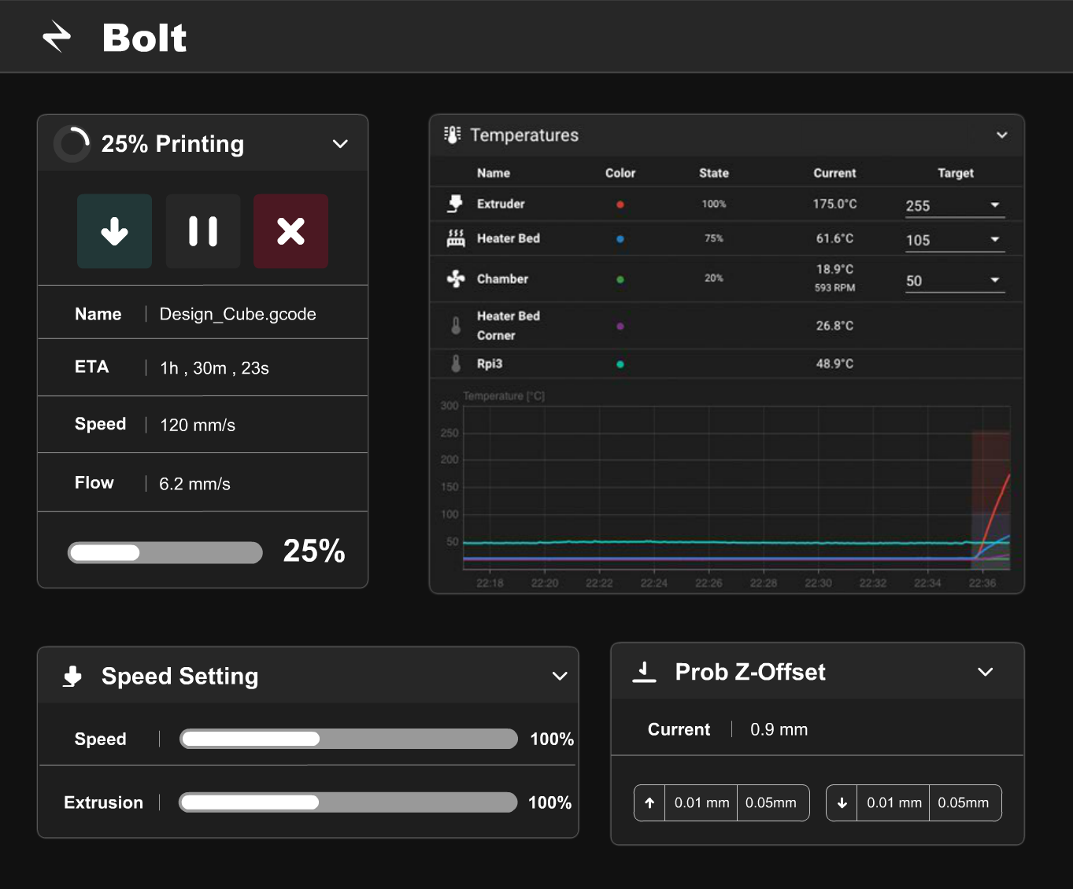

By integrating these three components seamlessly, our project will deliver an accessible and affordable 3D printer that not only addresses the challenges of Pakistan's manufacturing landscape but also provides a userfriendly and versatile platform for individuals and businesses to harness the power of 3D printing technology. The combination of hardware precision, software optimization, and a userfriendly web interface will make 3D printing more accessible and beneficial for a wide range of applications, from engineering and building design to rapid prototyping and manufacturing.

**Contributions to Pakistan:**

Our initiative goes beyond providing an affordable and accessible 3D printer. It contributes to Pakistan's development in several ways:

**1. Technological Advancement**: By democratizing access to 3D printing technology, we empower individuals and organizations across Pakistan to innovate, prototype, and manufacture locally.

**2. Local Sourcing:** Our commitment to sourcing components and materials from local markets supports the growth of the domestic supply chain and reduces reliance on costly imports, boosting the local economy.

**3. Skills Development:** By simplifying 3D printing and offering an opensource platform, we promote skills development, enabling individuals to acquire expertise in 3D printing technology

**Deliverables for "BOLT”:**

* Open-Source Design and Software
* User-Friendly Web Interface
* Guide on How to Build the 3D Printer
* Downloadable 3D Printable Files
* Hardware Sources for Components
* Accessible and Affordable 3D Printer
* Comprehensive Project Documentation

**Technologies Utilized:**

* Firmware (Klipper, Marlin)
* Website Development (Vue.js, JavaScript Framework)
* Boot Flasher
* PlatformIO
* Arduino Environment
* Pronterface for Calibration

**Business Model:**

**Project Methodology:**

1. **Proposal Development (4 weeks):** Initiate the project by crafting a comprehensive proposal that outlines project objectives, scope, and initial planning.
2. **Requirements Analysis (3 weeks):** Define the specific technical requirements for the 3D printer, encompassing core XY motion, necessary software, and essential hardware components.
3. **3D Model Design (3 weeks):** Proceed to design the 3D model of the printer while meticulously analyzing it against the defined requirements.
4. **Implementation and Development (3 weeks):** Dive into the actual development phase, which includes tasks like printing printable files, procuring essential hardware and software components, and beginning the integration process.
5. **Web Interface Integration (3 weeks):** Develop the user-friendly web interface for controlling the 3D printer and ensure it seamlessly integrates with the hardware and software.
6. **Implementation Documentation (1 week):** Create detailed implementation documentation that will serve as a guide for the entire development process.
7. **Testing and Integration (4 weeks**): Rigorously test each component and integrate them, ensuring that they work in harmony to meet project goals.
8. **Refinement of Documentations (4 weeks):** Review and enhance all project documentation for clarity, precision, and accuracy.
9. **Feedback and Bug Testing (4 weeks):** Actively seek feedback from stakeholders, implement necessary changes, and engage in comprehensive bug testing and resolution**.**
10. **Final Testing (2 weeks):** Conduct a final round of testing to ensure the 3D printer's functionality, reliability, and readiness for deployment.
11. **Deployment (2 weeks):** Prepare for the official deployment and launch of the accessible and affordable 3D printer, making it available to users and stakeholders.

**Timelines:**

**Timeline:**

* Proposal Development (4 weeks)
* Requirements Analysis (3 weeks)
* 3D Model Design (3 weeks)
* Implementation and Development (3 weeks)
* Web Interface Integration (3 weeks)
* Implementation Documentation (1 week)
* Testing and Integration (4 weeks)
* Refinement of Documentations (4 weeks)
* Feedback and Bug Testing (4 weeks)
* Final Testing (2 weeks)
* Deployment (1 week)

**Gantt chart:**

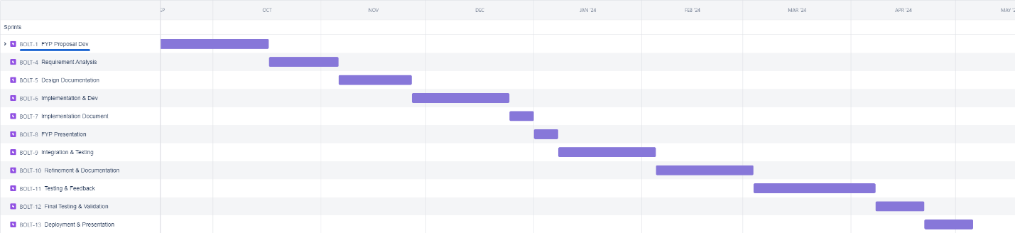

**Previous 3D Printing Experience (Expertise):**

Prior to embarking on our project to develop an accessible and affordable 3D printer for Pakistan, I have gained valuable experience in 3D printing, including:

**1. Maintenance and Repair:** Successfully maintained and fixed two 3D printers, gaining expertise in diagnosing and resolving printer issues.

**2. Filament Extruder Machine:** Designed and built a filament extruder machine, demonstrating proficiency in working with complex machinery for filament production.

**3. Firmware Modification:** Independently modified the firmware of my old 3D printer, adding new features and conducting thorough testing and debugging.

These experiences have equipped me with practical skills and insights essential for our project's success.

In conclusion, our proposal outlines a comprehensive plan for the development of an accessible and affordable 3D printer tailored to the specific needs and challenges of Pakistan. This initiative will not only reduce the financial barrier but also foster local expertise and innovation in 3D printing technology, ultimately contributing to the growth of Pakistan's manufacturing and technology sector.

**Paper References:**

**[1]** Kainat Waseem, Dr. Hasnain Alam Kazmi, & Ovais Hussain Qureshi. (2016). INNOVATION IN EDUCATION - Inclusion of 3D-Printing Technology in Modern Education System of Pakistan: Case from Pakistani Educational Institutes. Journal of Education and Practice, 7(36).

**[2]** Azhar, Aashir & Nazir, Aamer & Qureshi, Waheeda & Jeng, Jeng-Ywan. (2019). Accelerating Research and Development Using 3D Printing and Its Potential Opportunities in Pakistan: A Review. 1-8. 10.1109/ICRAI47710.2019.8967387.